# INTRODUCTION

* 1. Overview

Are you new to Salesforce? Not sure exactly what it is, or how to use it? Don’t know where you should start on your learning journey? If you’ve answered yes to any of these questions, then you’re in the right place. This module is for you. Welcome to Salesforce!

* 1. Purpose

The primary goal of an Applicant Tracking System is to simplify the recruitment process and to make it more effective and efficient.

1. **ProblemDefinition& DesignThinking**
   1. EmpathyMap

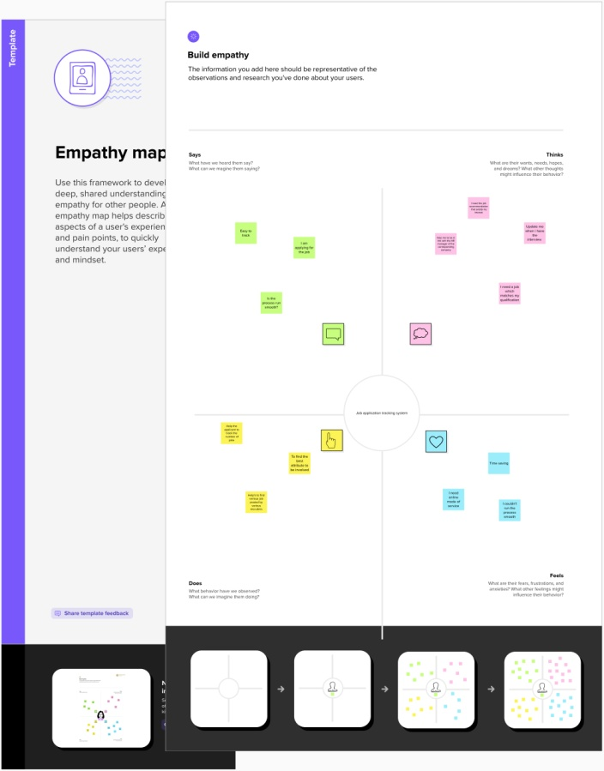

* 1. Ideation&BrainstormingMap

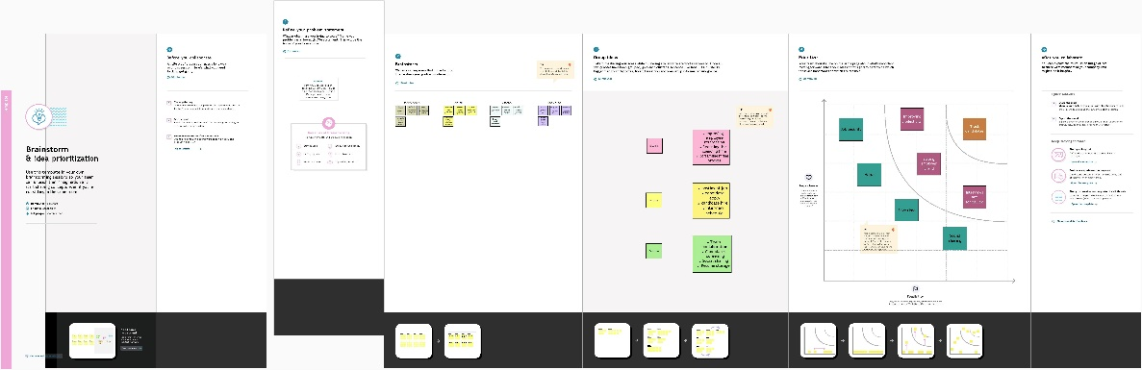

# RESULT

* 1. DataModel:

|  |  |
| --- | --- |
| Object Name | Fields in the object |
| Recruiter | |  |  | | --- | --- | | Field Label | Data Type | | Recruiter | Auto Number | |
| Jobs | |  |  | | --- | --- | | Field Label | Data Type | | Jobs | Text | |
| Candidate | |  |  | | --- | --- | | Field Label | Data Type | | Candidate | Text | |
| Job Application  Object | |  |  | | --- | --- | | Field Label | Data Type | | Job Application Object | Text | |
| Tab | |  |  | | --- | --- | | Field Label | Data Type | | Tab | Text | |

# Activity&Screenshot

SALESFORCE

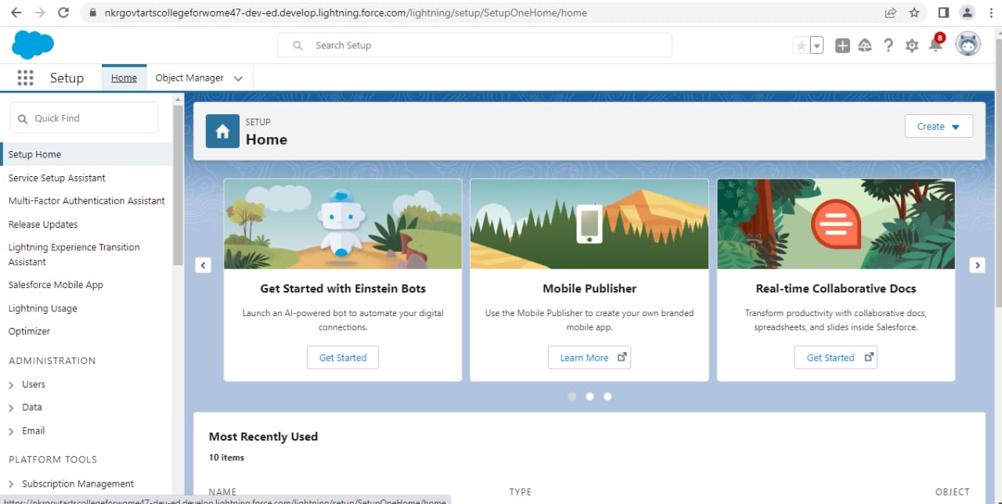

OBJECT

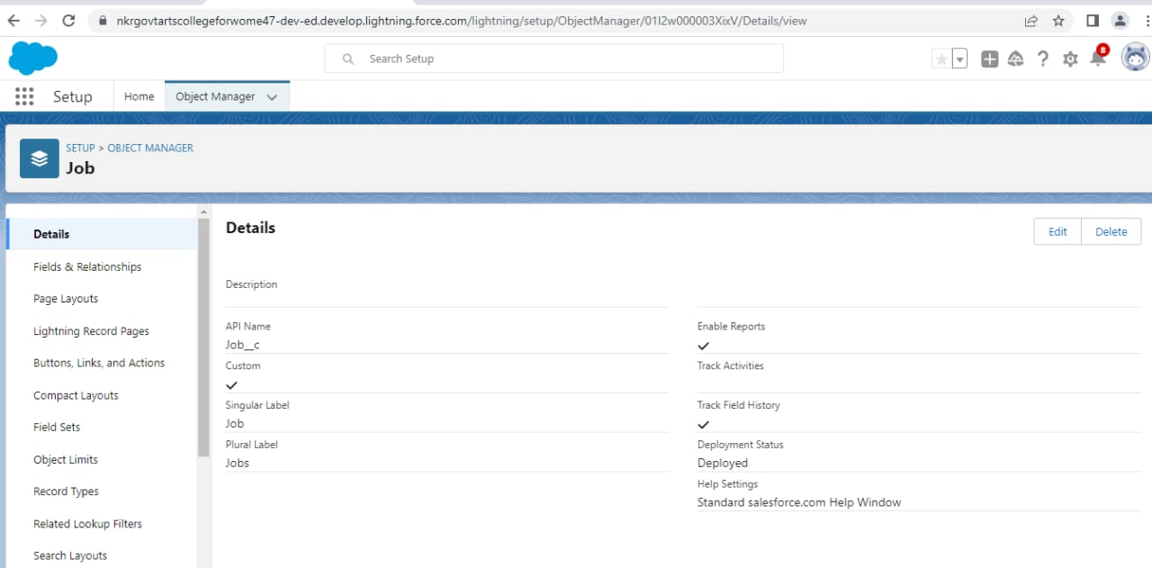

Description

We create the object like recruiter, jobs ,candidate, job ,

Application in the object Manager.

FIELDS

We create the field for the objects with suitable data type in

The object Manager tab.

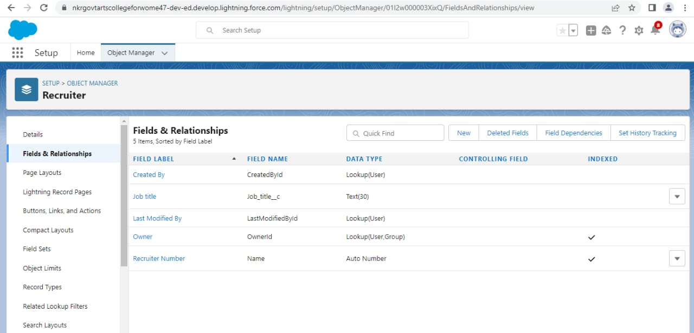

Tab

A tab is small pieces of cloth or paper that is attached to something.

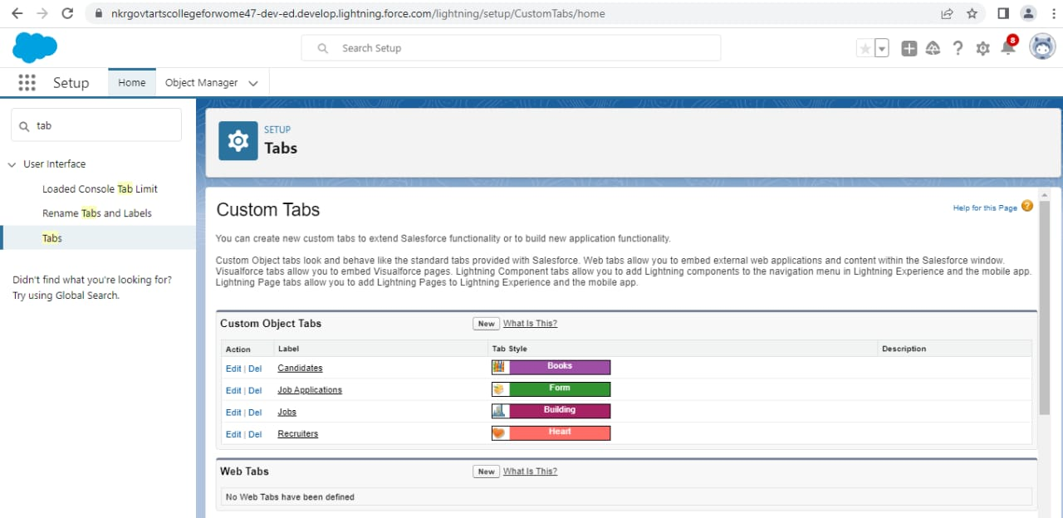

Profile

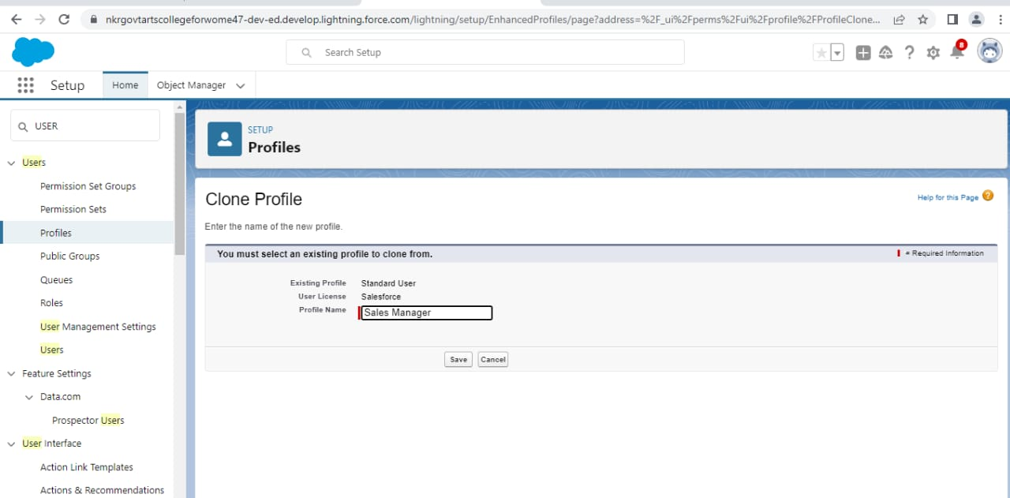

A profile is a group collection of setting permissions that define what a user can do in salesforce.

User

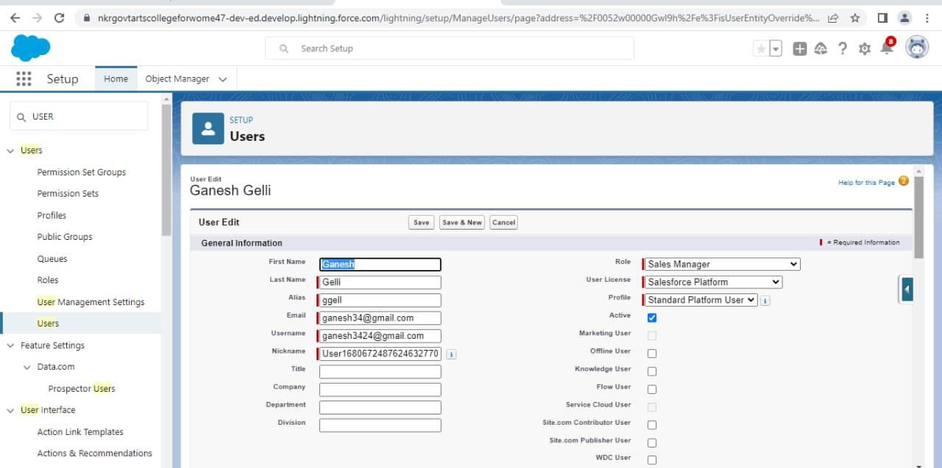 User is someone who emplus our uses a particular thing.

Sharing settings

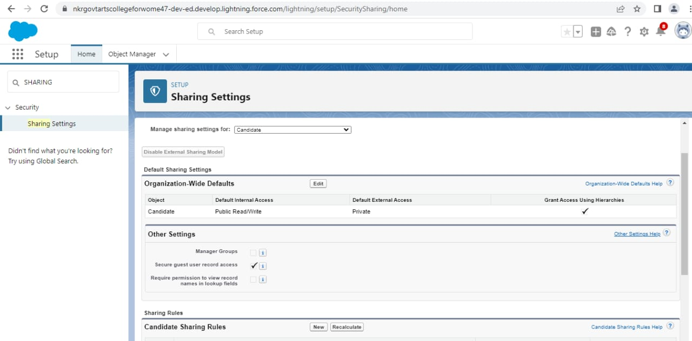

Reports

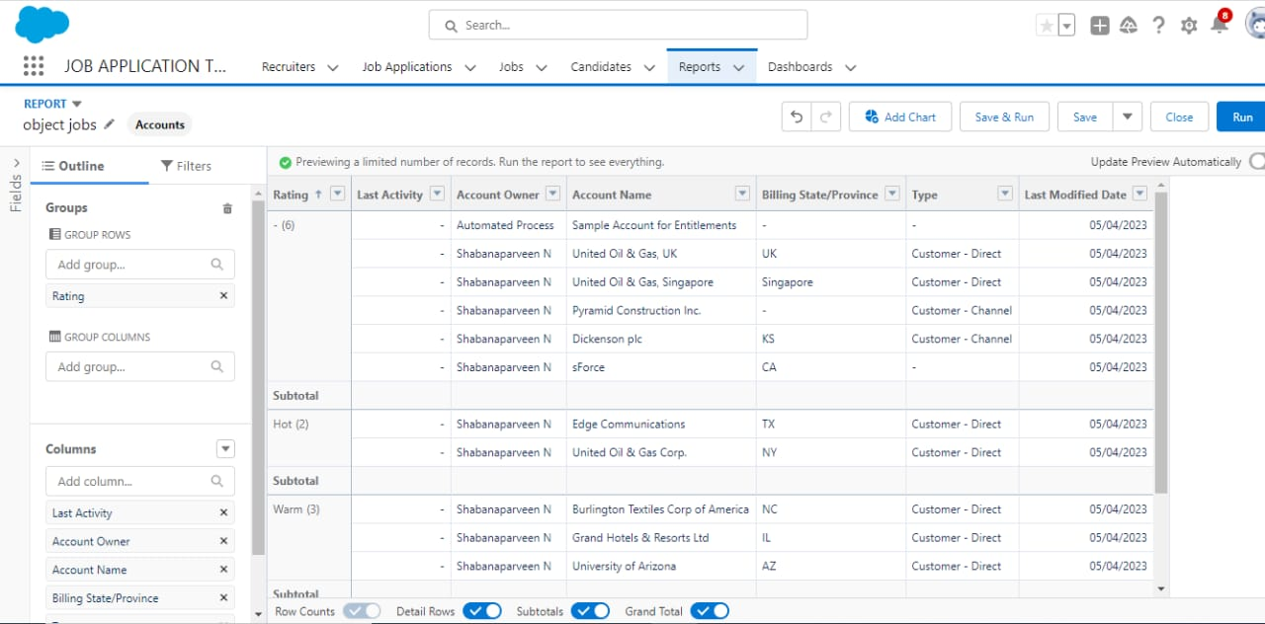

An account or statement describing in detailan event, situation, or the like, usually as the result of observation, inquirey.

# TrailheadProfilePublicURL

**Team Lead** <https://trailblazer.me/id/manorama>

**Team Member 1-**<https://trailblazer.me/id/uarthip>

**Team Member 2-**<https://trailblazer.me/id/ssugan30>

**Team Member 3-**<https://trailblazer.me/id/uvimalas>

1. **ADVANTAGES&DISADVANTAGE**

Advantages

1.Easy Job posting

2.Better overview of application

3.Saves time for value added work

4.Faster and Better Decision

Disadvantages

A Disadvantage of ATS is missing qualified applicants due to wrong keyword selection.

Automatic elimination of resumes that software cannot recognize and interpret is another drawback of ATS.

An Applicant Tracking System Disadvantage is that they are open to manipulation.

# APPLICATIONS

Streamlines recruiting. ...

Posts jobs on multiple job boards. ...

Saves time by automating mundane tasks. ...

Builds your brand.

# CONCLUSION

Applicant Tracking System for recruiters is a very effective hiring solution that most of the successful recruiters utilize.

# FUTURESCOPE

Traditional Applicant Tracking System. ...

Modern Applicant Tracking System. ...

ATS Will Begin to Look and Act More Like Social Network.